SMART CALENDAR OPTIMIZER
Nysha Katiyar
23FE10CII00031

INTRODUCTION
In today’s fast-paced digital world, efficient time management is crucial for both individuals and organizations. Traditional calendar systems, while functional, often fall short in offering intelligent, automated, and context-aware scheduling capabilities. With the rise of Internet of Things (IoT) and Artificial Intelligence (AI), there is a growing opportunity to revolutionize how we plan, organize, and execute daily tasks and appointments.
The Smart Calendar is an innovative solution designed to address the limitations of conventional scheduling tools. By integrating with smart devices and cloud services, it enables seamless synchronization, real-time updates, and intelligent task management. Powered by AI, the Smart Calendar can analyze user behavior, predict optimal scheduling times, and automatically adapt to changes in routine—offering a personalized and proactive scheduling experience.
As affective time management remains a critical challenge in both professional and personal contexts. Traditional calendar applications (e.g., Google Calendar, Outlook) require manual event scheduling, which is time-consuming and often fails to optimize for:
- User preferences (e.g., energy levels, priority tasks)
- Temporal constraints (e.g., travel time between meetings)
- Dynamic adjustments (e.g., last-minute changes)
The Smart Calendar Optimizer addresses these limitations by introducing AI-driven automation and mathematical optimization to create schedules that maximize productivity while minimizing conflicts
This report explores the architecture, technologies, and practical applications of the Smart Calendar system. It also highlights how this solution can enhance productivity across various sectors, including education, healthcare, and business, by automating reminders, optimizing schedules, and improving resource utilization. As digital ecosystems become increasingly interconnected, Smart Calendars are set to become a cornerstone of smart living and working environments.
Now, here is the implementation :
- To launch the Smart Calendar's web interface using Streamlit within Visual Studio Code, use the following command in your terminal:
streamlit run app.py
This command will start a local web server and open the interface in your default web browser, enabling real-time interaction with the Smart Calendar UI

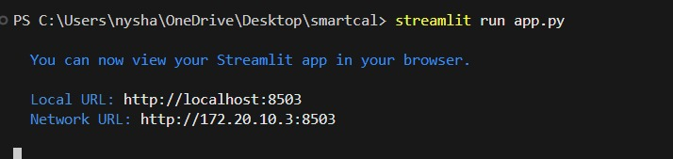
Fig1 Streamlit command to run interface in VS code
- The Smart Calendar interface offers a clean, user-friendly design built with Streamlit. It allows users to add, view, and manage events effortlessly. Integrated with real-time updates and smart suggestions, the interface dynamically adapts based on user preferences and connected devices.
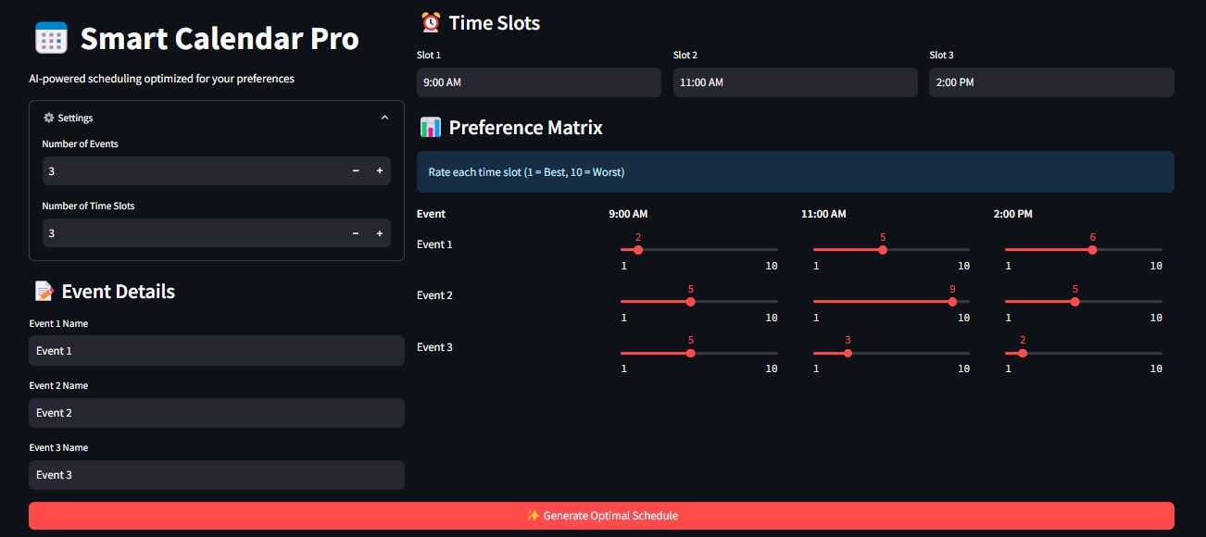Fig 2 Basic interface of Smart Calendar
- This screen indicates successful optimization of the user's schedule using intelligent algorithms. Conflicts are resolved, and the final calendar is tailored to user preferences, device availability, and time constraints — ensuring maximum productivity and convenience.
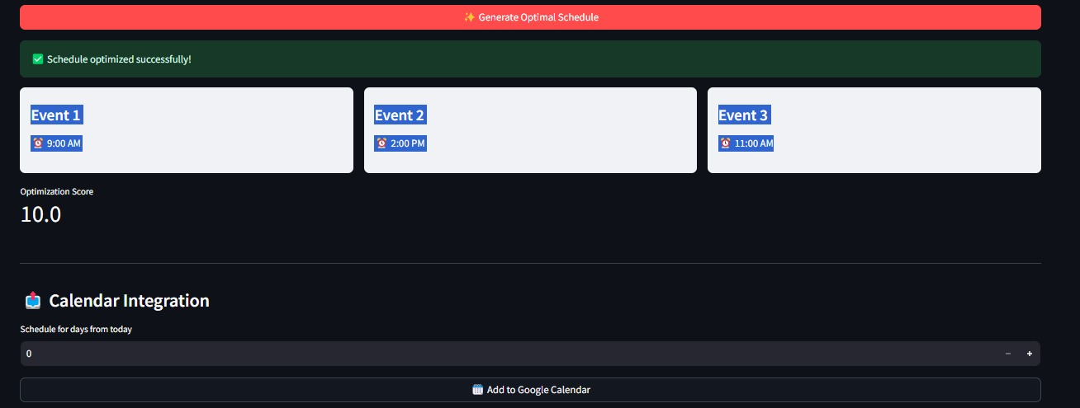
Fig 3 Optimized Successfully
- The optimization process begins with the user interface collecting events, available slots, and user preferences. The SmartScheduler module then selects the most suitable algorithm (e.g., Branch & Bound, Hungarian, or Genetic Algorithm) to compute the optimal schedule. This output is translated into human-readable time slots, which are seamlessly pushed to the user's Google Calendar via its API.

- The Smart Calendar seamlessly integrates with external services like Google Calendar. This ensures real-time syncing of events, allowing users to manage all schedules from a unified interface while maintaining consistency across devices and platforms.
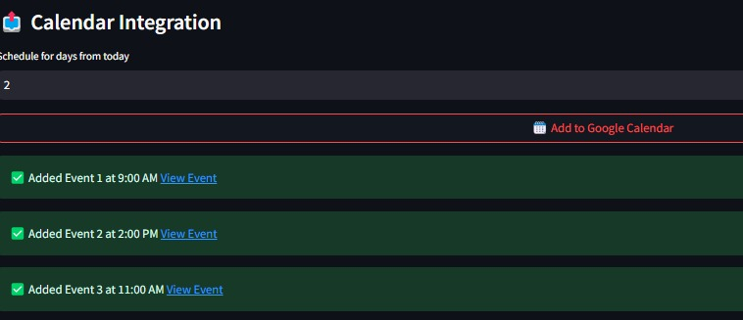
Fig 4 Calendar integration
- This figure shows the Smart Calendar’s synchronized output reflected in Google Calendar. Events scheduled through the intelligent interface are automatically updated, ensuring the user’s digital calendar remains accurate, up-to-date, and accessible across devices.
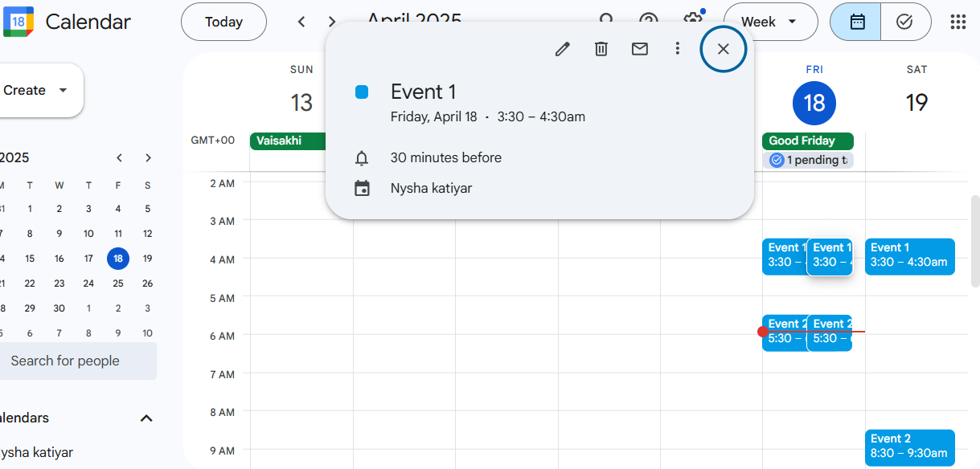
Fig 5 Response in Google Calendar

Codes:
Done in VS Code in Python.
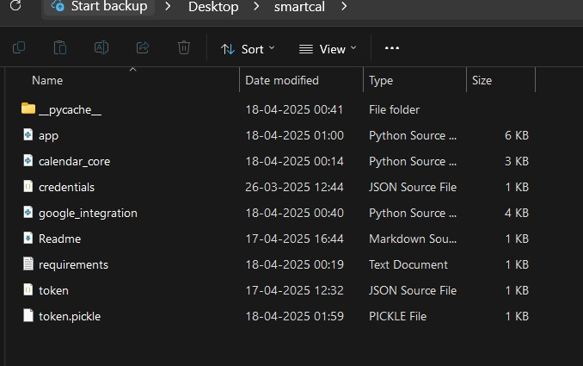
Calendar_core.py:
import numpy as np
import itertools # <-- THIS WAS MISSING
from scipy.optimize import linear_sum_assignment
from deap import algorithms, base, creator, tools
import random

class SmartScheduler:
def __init__(self):
self.setup_genetic_algorithm()

def setup_genetic_algorithm(self):
creator.create("FitnessMin", base.Fitness, weights=(-1.0,))
creator.create("Individual", list, fitness=creator.FitnessMin)

def optimize(self, events, time_slots, preferences):
"""Automatically selects best scheduling algorithm"""
num_events = len(events)
num_slots = len(time_slots)

if num_events <= 5:
return self.branch_and_bound(events, time_slots, preferences)
elif num_events == num_slots:
return self.hungarian_algorithm(events, time_slots, preferences)
else:
return self.genetic_algorithm(events, time_slots, preferences)

def branch_and_bound(self, events, time_slots, preferences):
"""Optimal for small problems (≤5 events)"""
best_schedule, best_score = None, float('inf')
for perm in itertools.permutations(range(len(time_slots))):
score = sum(preferences[i, perm[i]] for i in range(len(events)))
if score < best_score:
best_score, best_schedule = score, perm
return [time_slots[i] for i in best_schedule], best_score

def hungarian_algorithm(self, events, time_slots, preferences):
"""Optimal for equal numbers of events and slots"""
row_ind, col_ind = linear_sum_assignment(preferences)
return [time_slots[i] for i in col_ind], preferences[row_ind, col_ind].sum()

def genetic_algorithm(self, events, time_slots, preferences):
"""Best for complex/large schedules"""
toolbox = base.Toolbox()
toolbox.register("permutation", random.sample, range(len(time_slots)), len(time_slots))
toolbox.register("individual", tools.initIterate, creator.Individual, toolbox.permutation)
toolbox.register("population", tools.initRepeat, list, toolbox.individual)
toolbox.register("mate", tools.cxPartialyMatched)
toolbox.register("mutate", tools.mutShuffleIndexes, indpb=0.1)
toolbox.register("select", tools.selTournament, tournsize=3)
toolbox.register("evaluate", lambda ind: sum(preferences[i, ind[i]] for i in range(len(events))))

pop = toolbox.population(n=200)
algorithms.eaSimple(pop, toolbox, cxpb=0.7, mutpb=0.2, ngen=100)

best = tools.selBest(pop, k=1)[0]
return [time_slots[i] for i in best], toolbox.evaluate(best)[0]

App.py:
import streamlit as st
import numpy as np
from calendar_core import SmartScheduler
from google_integration import GoogleCalendarManager

# ===== WIDE LAYOUT CONFIG =====
st.set_page_config(
page_title="Smart Calendar Optimizer",
layout="wide", # <-- THIS MAKES IT WIDE
initial_sidebar_state="expanded"
)

# Custom CSS for better spacing
st.markdown("""
<style>
.block-container {
padding-top: 2rem;
padding-bottom: 2rem;
}
.stButton>button {
width: 100%;
}
.stSlider {
padding: 0 1rem;
}
</style>
""", unsafe_allow_html=True)
st.markdown("""
<style>
.event-card {
padding: 1rem;
border-radius: 10px;
margin: 0.5rem 0;
box-shadow: 0 2px 4px rgba(0,0,0,0.1);
border-left: 4px solid #4CAF50;
}
.event-name {
font-weight: 600;
font-size: 1.1rem;
color: #2c3e50;
}
.event-time {
color: #7f8c8d;
font-size: 0.9rem;
}
</style>
""", unsafe_allow_html=True)

def main():
# Initialize services
scheduler = SmartScheduler()
calendar_manager = GoogleCalendarManager()

# ===== MAIN COLUMNS =====
col1, col2 = st.columns([1, 2]) # Wider right column

with col1:
st.title("📅 Smart Calendar Pro")
st.write("AI-powered scheduling optimized for your preferences")

# ===== SETTINGS =====
with st.expander("⚙️ Settings", expanded=True):
num_events = st.number_input("Number of Events", 1, 20, 2)
num_slots = st.number_input("Number of Time Slots", 1, 20, 3)

# ===== EVENT DETAILS =====
st.subheader("📝 Event Details")
events = [st.text_input(f"Event {i+1} Name", f"Event {i+1}", key=f"event_{i}")
for i in range(num_events)]

with col2:
# ===== TIME SLOTS =====
st.subheader("⏰ Time Slots")
time_cols = st.columns(num_slots)
default_times = ["9:00 AM", "11:00 AM", "2:00 PM", "4:00 PM"]
time_slots = []

for i in range(num_slots):
with time_cols[i]:
time_slots.append(st.text_input(
f"Slot {i+1}",
default_times[i] if i < len(default_times) else "",
key=f"time_{i}"
))

# ===== PREFERENCES GRID =====
st.subheader("📊 Preference Matrix")
st.info("Rate each time slot (1 = Best, 10 = Worst)")

preferences = np.zeros((num_events, num_slots))
grid = st.columns(num_slots + 1)

# Header row
with grid[0]:
st.markdown("**Event**")
for j in range(num_slots):
with grid[j+1]:
st.markdown(f"**{time_slots[j]}**")

# Preference sliders
for i in range(num_events):
grid = st.columns(num_slots + 1)
with grid[0]:
st.markdown(f"{events[i]}")
for j in range(num_slots):
with grid[j+1]:
preferences[i,j] = st.slider(
f"{events[i]} @ {time_slots[j]}",
1, 10, 5,
key=f"pref_{i}_{j}",
label_visibility="collapsed"
)

# ===== SCHEDULE GENERATION =====
if st.button("✨ Generate Optimal Schedule", type="primary"):
with st.spinner("Optimizing your schedule..."):
try:
schedule, score = scheduler.optimize(events, time_slots, preferences)

st.success("✅ Schedule optimized successfully!")

# Display schedule in a nice card layout
cols = st.columns(len(schedule))
for idx, (event, slot) in enumerate(zip(events, schedule)):
with cols[idx]:
st.markdown(f"""
<div style='
padding: 1rem;
border-radius: 0.5rem;
background: #f0f2f6;
margin-bottom: 1rem;
'>
<h4>{event}</h4>
<p>⏰ {slot}</p>
</div>
""", unsafe_allow_html=True)

st.metric("Optimization Score", score)

# Store results
st.session_state.events = events
st.session_state.schedule = schedule

except Exception as e:
st.error(f"❌ Error generating schedule: {str(e)}")

# ===== GOOGLE CALENDAR INTEGRATION =====
if 'schedule' in st.session_state:
st.divider()
st.subheader("📤 Calendar Integration")

days_ahead = st.number_input("Schedule for days from today", 0, 30, 0)

if st.button("🗓️ Add to Google Calendar", use_container_width=True):
with st.spinner("Adding to Google Calendar..."):
results = calendar_manager.add_events(
st.session_state.events,
st.session_state.schedule,
days_ahead
)

for result in results:
if result['status'] == 'success':
st.success(f"✅ Added {result['event']} at {result['time']} [View Event]({result['link']})")
else:
st.error(f"❌ Failed to add {result['event']}: {result['error']}")

if __name__ == "__main__":
main()
Google_integration.py:

import os
import pickle
from datetime import datetime, timedelta
from google.oauth2.credentials import Credentials
from google_auth_oauthlib.flow import InstalledAppFlow
from google.auth.transport.requests import Request
from googleapiclient.discovery import build # <-- THIS WAS MISSING

# Google Calendar API settings
SCOPES = ['https://www.googleapis.com/auth/calendar']
TIMEZONE = "Asia/Kolkata" # Change to your timezone

class GoogleCalendarManager:
def __init__(self):
self.creds = None
self.token_file = 'token.pickle'
self.credentials_file = 'credentials.json'
self.service = self.authenticate()

def authenticate(self):
"""Handles OAuth 2.0 authentication"""
# Load existing credentials
if os.path.exists(self.token_file):
with open(self.token_file, 'rb') as token:
self.creds = pickle.load(token)

# If no valid credentials, log in
if not self.creds or not self.creds.valid:
if self.creds and self.creds.expired and self.creds.refresh_token:
self.creds.refresh(Request())
else:
flow = InstalledAppFlow.from_client_secrets_file(
self.credentials_file, SCOPES)
self.creds = flow.run_local_server(port=0)

# Save credentials
with open(self.token_file, 'wb') as token:
pickle.dump(self.creds, token)

return build('calendar', 'v3', credentials=self.creds)

def add_events(self, events, time_slots, days_ahead=0):
"""Add events to Google Calendar"""
base_date = datetime.now() + timedelta(days=days_ahead)
results = []

for event_name, time_slot in zip(events, time_slots):
try:
# Parse time slot (e.g., "2:00 PM")
time_str, period = time_slot.split()
hours, minutes = map(int, time_str.split(':'))

if period.upper() == 'PM' and hours != 12:
hours += 12
elif period.upper() == 'AM' and hours == 12:
hours = 0

start_time = base_date.replace(hour=hours, minute=minutes)
end_time = start_time + timedelta(hours=1) # Default 1-hour duration

event = {
'summary': event_name,
'start': {
'dateTime': start_time.isoformat(),
'timeZone': TIMEZONE,
},
'end': {
'dateTime': end_time.isoformat(),
'timeZone': TIMEZONE,
},
}

created_event = self.service.events().insert(
calendarId='primary',
body=event
).execute()

results.append({
'status': 'success',
'event': event_name,
'time': time_slot,
'link': created_event.get('htmlLink')
})

except Exception as e:
results.append({
'status': 'error',
'event': event_name,
'error': str(e)
})

return results

Requirements.txt:
streamlit==1.28.0
numpy==1.24.3
scipy==1.10.1
deap==1.3.3
streamlit==1.28.0
numpy==1.24.3
scipy==1.10.1
deap==1.3.3
google-api-python-client==2.84.0
google-auth-oauthlib==1.0.0
python-dotenv==1.0.0

